Cosmetic Tattoo Aftercare - BROWS

You will be given a small tube of aftercare cream. This is a gentle antiseptic cream which assists in the skin's natural healing process. It will prevent infections and scabbing and will hydrate and soothe the tattooed area.
Use a damp, warm cotton pad to gently dab (NOT RUB OR WIPE) your brow area to remove any lymph fluid or old healing cream. You can then apply a fresh layer of healing cream (apply with a q-tip, not your finger). Do this, 3 times a day until scabbing has finished. Do not worry if some of the colour comes out when applying cream, this is normal.
Avoid direct sun exposure on the brows for the first 2 weeks. Exposure to the sun over time can cause fading and may cause the colour to change. If you are going out into the sun apply sunscreen to protect the area & wear a hat once they are finished scabbing & peeling.
No make-up is to be applied on the treated area at least 48 hours. This can lead to infection and the colour to change.
No soap or cleansers on the brow area for 5-10 days.
Do not scrub, pick, itch or pull the brow area. Crusting will fall off naturally please do not force it.
Skin topicals that contain acids or retinol may lighten the colour prematurely with continuous use. Do not use any 'active' skincare products on the treated area. These include, Retinol, AHA, BHA, Vitamin C etc.
Do not use prescription Retin-A or Roaccutane for at least 2 weeks prior to treatment and 4 weeks after the treatment.
No fillers or anti-wrinkle injections such as Botox on or near the treated areas 2 weeks before or after treatment.
Do not sit in a heated spa, sauna, or steam room 2 weeks. Steam will open pores and may make the colour bleed out.
Do not wax, pluck, tint or bleach the hair for at least 2 weeks after the treatment.
No excessive exercise or sweating 24-48 hours post treatment.

Immediately after your brow tattoo, the area treated will look about 30-50% darker than the final results. The colour will lighten and soften over 3 to 14 days. It is normal for the area to feel slightly tender or dry.
Swelling is minimal and, in most clients, this will disappear within 24 hours. This will not stop you from working, socialising. The healing process is usually completed by week 3 and you are left with a muted and soft implanted colour.
The colour will be intense for the first 5 days, then they will appear much lighter, maybe even too light as the scabs fall off. Do not remove, itch, or pick scabs as this will also remove pigment from your skin.
Please wait until the 4-week mark to see the true colour and fully healed result. If you look closely, you may notice some colour coming back by the 3rd or 4th week. My saying to describe the healing phase is "Too dark, too light, just right".
Brows will also shrink slightly as they heal. If your new brows feel thick and swollen, please wait until the 4-week mark to see the healed and final result.
You will need a touch up appointment at 6 weeks to fill in any gaps or change pigment and/or shape.
Brow tattoos can last anywhere from 6 months to 2 years depending on how you look after them, how quickly your body metabolised pigment and your skin type.

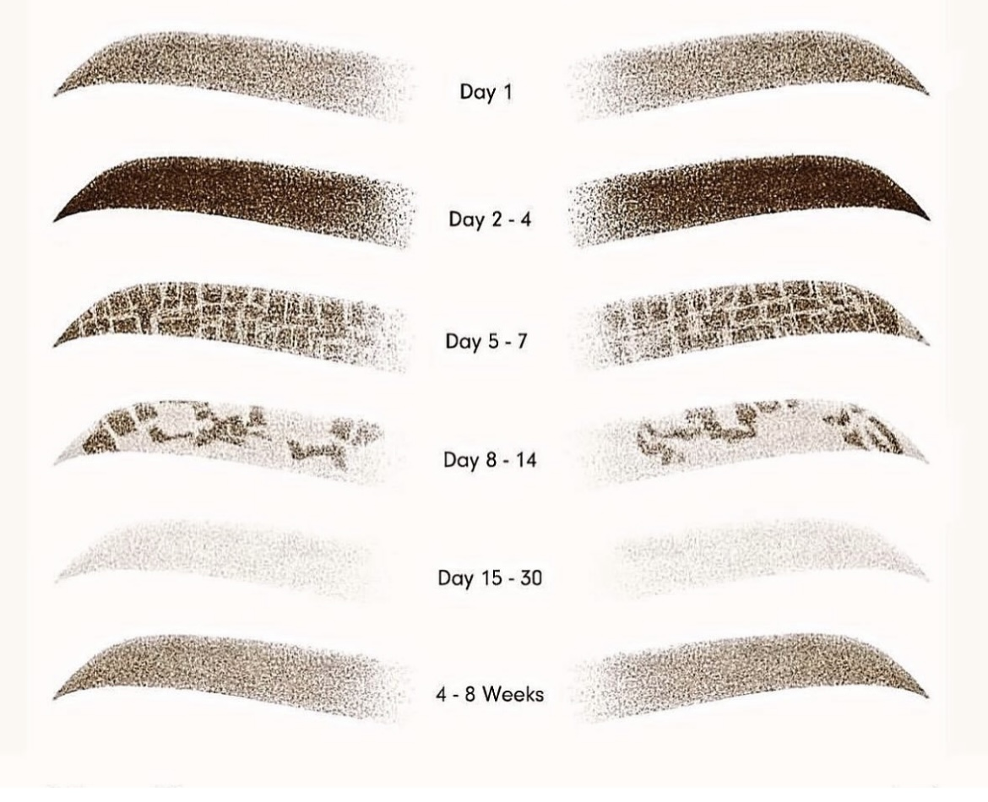

Cosmetic Tattoo Aftercare - LIPS

You will be given a small tube of aftercare cream. This is a gentle antiseptic cream which assists in the skin's natural healing process. It will prevent infections and scabbing and will hydrate and soothe the tattooed area.
Use a damp, warm cotton pad to gently dab (NOT RUB OR WIPE) your lip area to remove any lymph fluid or old healing cream. You can then apply a fresh layer of healing cream (apply with a q-tip, not your finger). Do this, 3 times a day until scabbing has finished. Do not worry if some of the colour comes out when applying cream, this is normal.
Avoid direct sun exposure on the lips for the first 2 weeks. Exposure to the sun over time can cause fading and may cause the colour to change. If you are going out into the sun apply sunscreen to protect the area & wear a hat once they are finished scabbing & peeling.
No make-up is to be applied on the lips area at least 48 hours. This can lead to infection and the colour to change.
No soap or cleansers on the lip area for 5-10 days.
Avoid using teeth whitening tooth paste. Chemicals of any kind can interfere with healing and the colour.
Do not scrub, pick, itch, lick or pull the lip area. Crusting will fall off naturally please do not force it.
Skin topicals that contain acids or retinol may lighten the colour prematurely with continuous use. Do not use any 'active' skincare products on the treated area. These include, Retinol, AHA, BHA, Vitamin C etc.
Do not use prescription Retin-A or Roaccutane for at least 2 weeks prior to treatment and 4 weeks after the treatment.
No fillers or anti-wrinkle injections such as Botox on or near the treated areas 2 weeks before or after treatment.
Do not sit in a heated spa, sauna, or steam room 2 weeks. Steam will open pores and may make the colour bleed out.
Do not wax, pluck, tint or bleach lip hair for at least 2 weeks after the treatment.
No excessive exercise or sweating 24-48 hours post treatment.

Lips will be very swollen post treatment and will last 24 - 48 hours. Use a cold compress if needed for 20 second intervals.
This area will be the quickest to heal. 4-5 days of scabbing and peeling. Do not pick, itch, or remove scabs as this will remove pigment prematurely. The colour when first done will be much brighter than the final healed colour. Your lips will fade to what looks like no pigment after the scabbing has finished and re-appears after 3-6 weeks once the deeper layers have healed.
Apply healing cream at least 3 times a day for 1 week to aid in healing.
If you suffer cold sore, take an anti-viral tablet right after your appointment.
You will need a touch up appointment at 6 weeks to fill in any gaps or change pigment and/or shape.
Lip tattoos can last anywhere from 6 months - 2 years depending on how you look after them, how quickly your body metabolised pigment and your skin type.

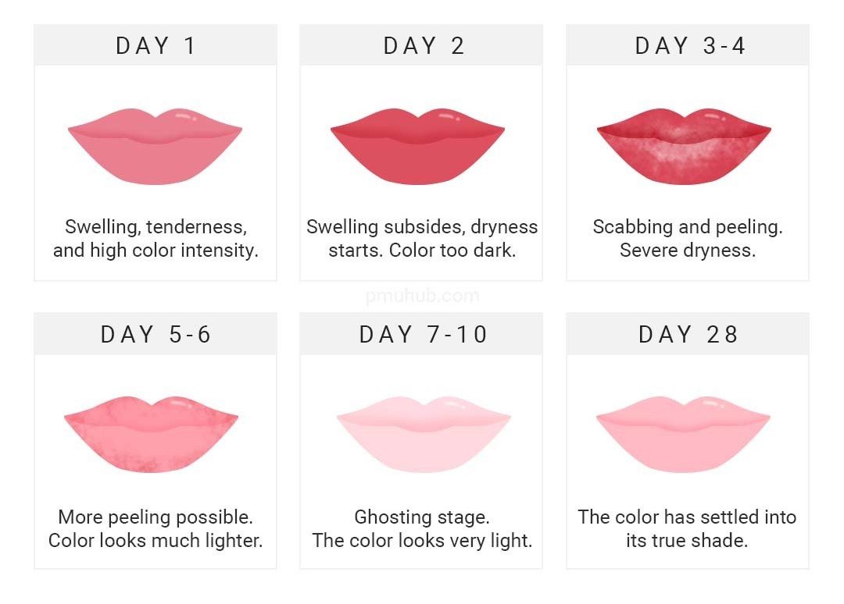

Cosmetic Tattoo Aftercare - EYELINER

Dry healing is recommended for eyeliner tattoo. No aftercare cream is required.
Avoid direct sun exposure on the eyes for the first 2 weeks. Exposure to the sun over time can cause fading and may cause the colour to change. If you are going out into the sun apply sunscreen to protect the area & wear a hat once they are finished scabbing & peeling.
No make-up is to be applied on the eye area at least 48 hours (especially mascara). This can lead to infection and the colour to change.
No soap or cleansers on the eye area for 5-10 days.
Do not rub, pick, itch, lick or pull the eye area. Crusting will fall off naturally please do not force it.
Skin topicals that contain acids or retinol may lighten the colour prematurely with continuous use. Do not use any 'active' skincare products on the treated area. These include, Retinol, AHA, BHA, Vitamin C etc.
Do not use prescription Retin-A or Roaccutane for at least 2 weeks prior to treatment and 4 weeks after the treatment.
No fillers or anti-wrinkle injections such as Botox on or near the treated areas 2 weeks before or after treatment.
Do not sit in a heated spa, sauna, or steam room 2 weeks. Steam will open pores and may make the colour bleed out.
Do not wax, pluck, tint or bleach lashes (included lash extensions and lifts) for at least 2 weeks after the treatment.
No excessive exercise or sweating 24-48 hours post treatment.

Expect the eye to be slightly tender 1-3 days. Swelling is minimal and with most clients it will subside within 24 hours. It is not necessary to apply any after care cream. If needed, cold pads can be applied to minimise swelling. Do not use eyeliner and mascara until fully healed.
You will need a touch up appointment at 6 weeks to fill in any gaps or change pigment and/or shape.
Eyeliner tattoos can last anywhere from 6 months - 2 years depending on how you look after them, how quickly your body metabolised pigment and your skin type.

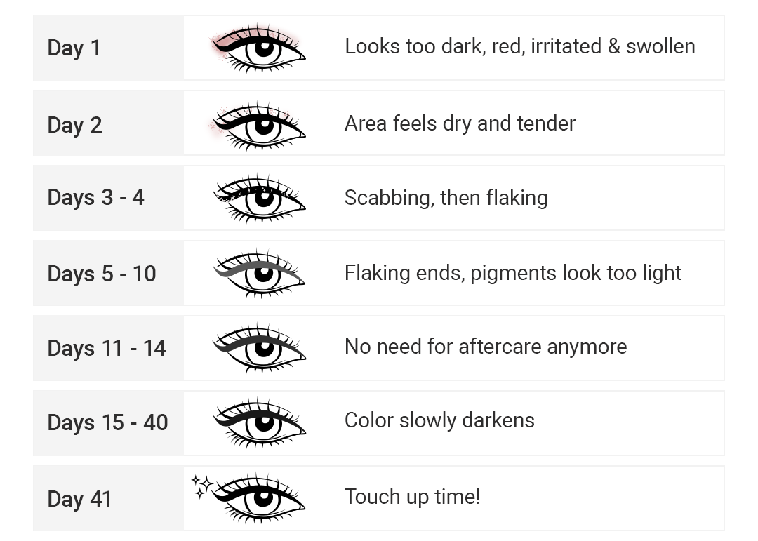

Cosmetic Tattoo Aftercare - NON-LASER TATTOO REMOVAL

Non-laser tattoo removal solution continues working after the treatment has finished. Dissolved pigment will keep rising in the skin and reach the surface to be easily removed in the second or third session. There will be slight swelling, as with any cosmetic tattoo service. It is best to leave the treatment area to dry naturally and let the body control the healing process. This process will take 6 - 8 weeks with minimum skin trauma.
After the procedure, you should wipe the treated area every 30mins for the first few hours to remove any blood, pigment, or lymph fluid that has risen to the surface. Removal will tend to form a slight crust or scab and can be gently dabbed using a clean, warm, damp cotton round if needed, but best to leave if possible and not be touched.
Sweating should be avoided for at least 3 days after the treatment.
Make-up cannot be worn for 7 days on the treated area to avoid infection.
The treatment area should be kept as dry and clean as possible and protected from water.

